Green Society Public School
D-

Ratnanagar-7, Sauraha, Chitwan
Annual Examination-2082
Class: One Time: - 1 hr. F.M: 25
Sub: Science
Name: Roll No.: Sec.:
________________ ______________ OBT.MARKS:
INVIGILATOR EXAMINER
Q no.1] Tick the best answer from the given alternatives. (2)
- When are stars observed?
i) morning ii) day iii) night
- Goats eat _________________.
i) grass ii) meat iii) plastic
- We get oxygen from the _________________.
i) animals ii) plants iii) house
- We wash our hair with_______________.
i) shampoo ii) water iii) both
Q no.2] Match the following. (3)
Mobile Big and strong
Tree Communication device
Rhino For drinking
Butterfly Land animal
Rain Insects
Water Source of water
Q no.3] Read the given information and identify who I am? (2)
- I am colorful part of plant ___________________.
- I found inside fruits _________________.
Qno.4] Write True or False. (3)
- Birds are cannot fly higher.
- A fish can swim in water.
- We should keep our classroom clean.
- I can smell with my nose.
- Crossing a river alone is good habit.
- Play with broken bottles is safe.
Q no.4] Answer the following questions. (8)
- Where do we get food from?
Ans:-_____________________________________________________________________.
- What are trees?
Ans:-_____________________________________________________________________.
- Write any two living things.
Ans:-_____________________________________________________________________.
- Write any two shrubs.
Ans:-_____________________________________________________________________.
Q no.5] Write the missing letters. (2)
Fl_____wer Ston_____ ______ood R_____ce
Q no.6] Write the name of parts of plant. (5)
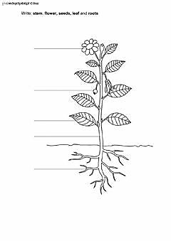
The End

